**Pemrograman 3**

**Nama : Dwi Adlina Putri**

**NIM : 4512210004**

Project : Aplikasi Cake Shop

Versi :

Creator: Dwi Adlina Putri

Tujuan :

* Menyimpan entri data kue ke dalam aplikasi
* Mengubah data kue yang sudah terdaftar dalam aplikasi

Ijinkan :

* Administrator bisa menambah/mengubah/menghapus data kue manapun

Penjelasan :

Cara menggunakan sistem ini :

* Pembeli kue memilih kue atau memesan kue
* Jika sudah pembeli langsung ke kasir, untuk melakukan proses transaksi
* User menginput kode / id kue
* User menginput jumlah kue yang dibeli sesuai dengan kategori dan nama kue
* Maka sistem akan memproses data kue yang sudah diinput oleh user dan menghitung jumlah total pembayaran
* Cetak struk total pembayaran
* Pembeli membayar total belanjaan dan langsung membawa pulang kue tersebut

Flow Aplikasi :

|  |  |  |  |
| --- | --- | --- | --- |
| Admin | *Server* | *Database* | *User* |
| Admin  login  Kategori | Sign In  Sign Up | Pilih | Bayar  Pesan |

Desain Screen

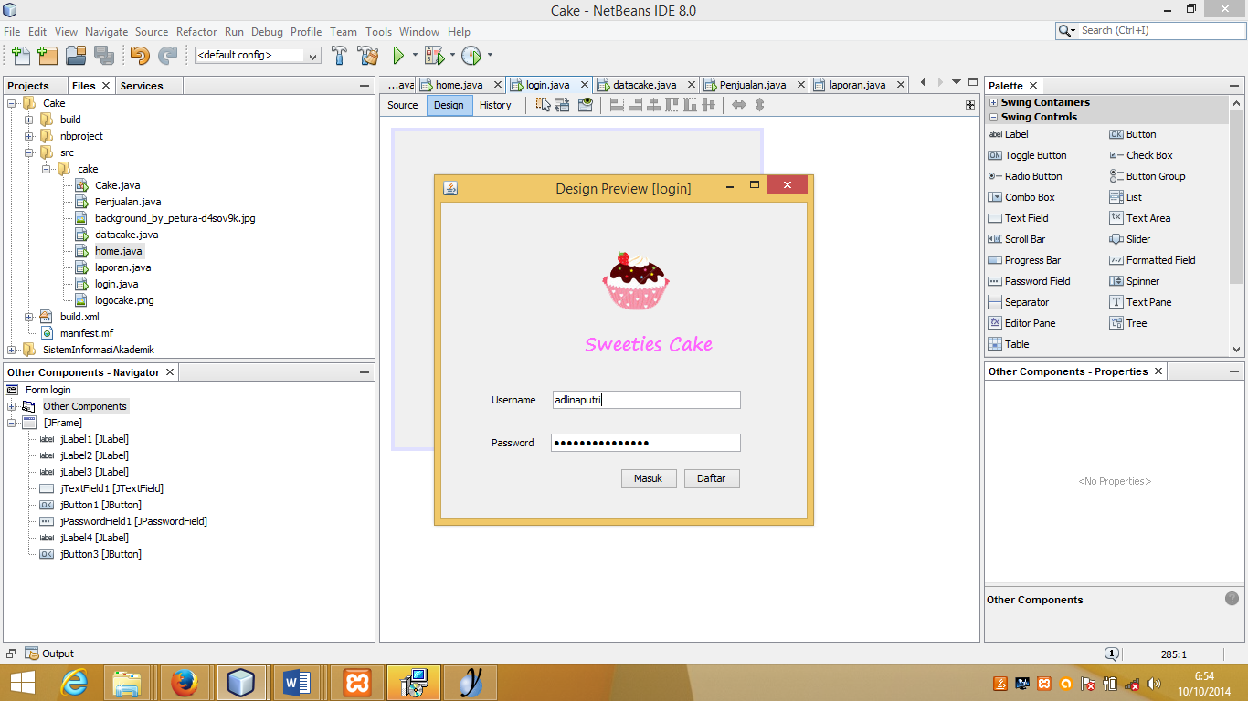

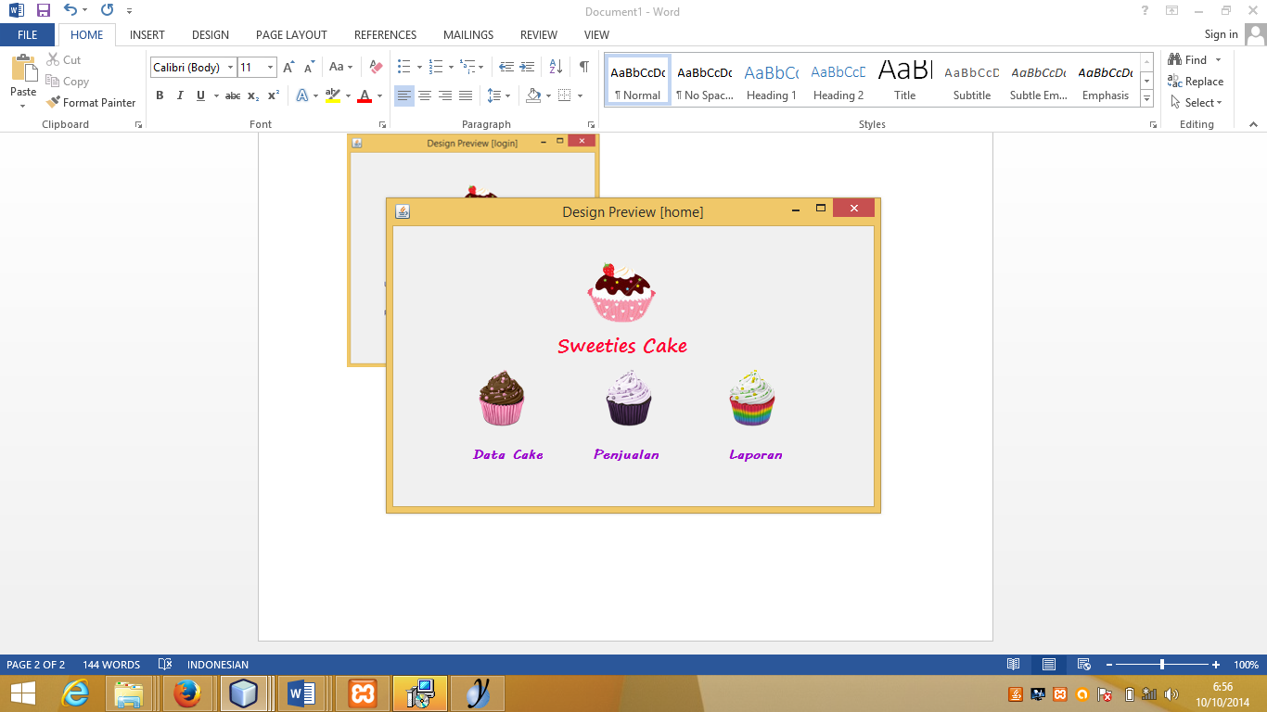

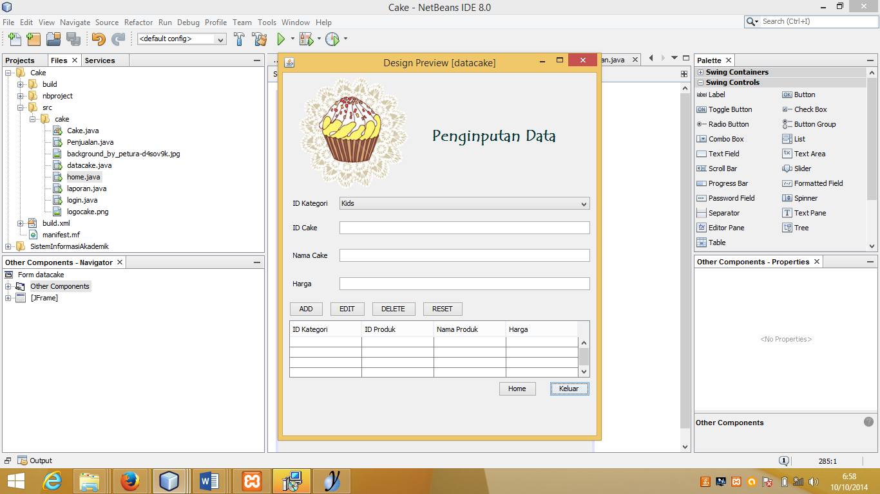

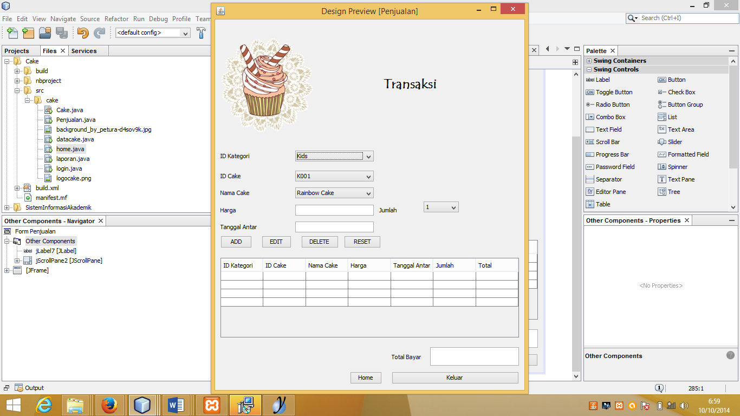

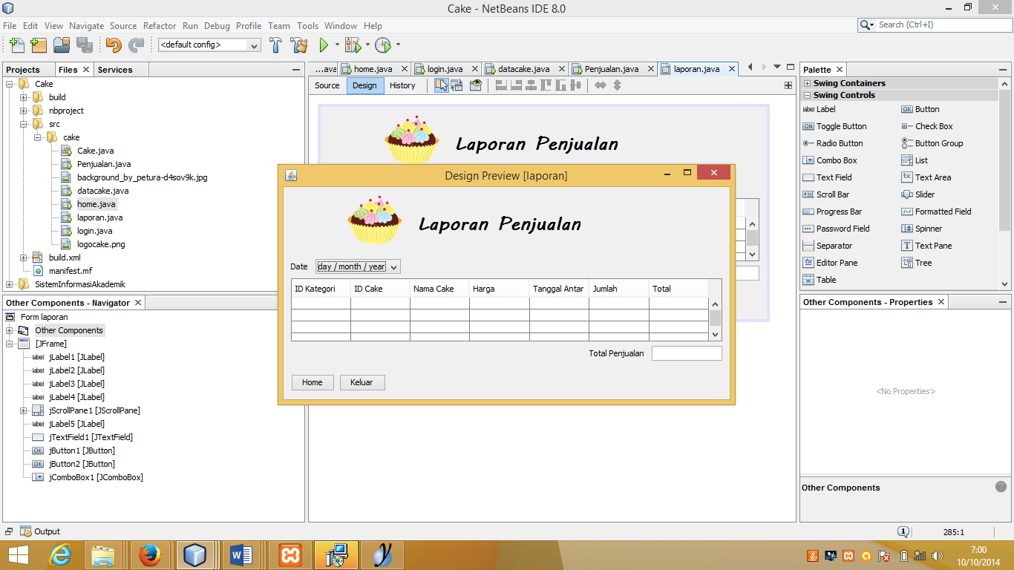

Database

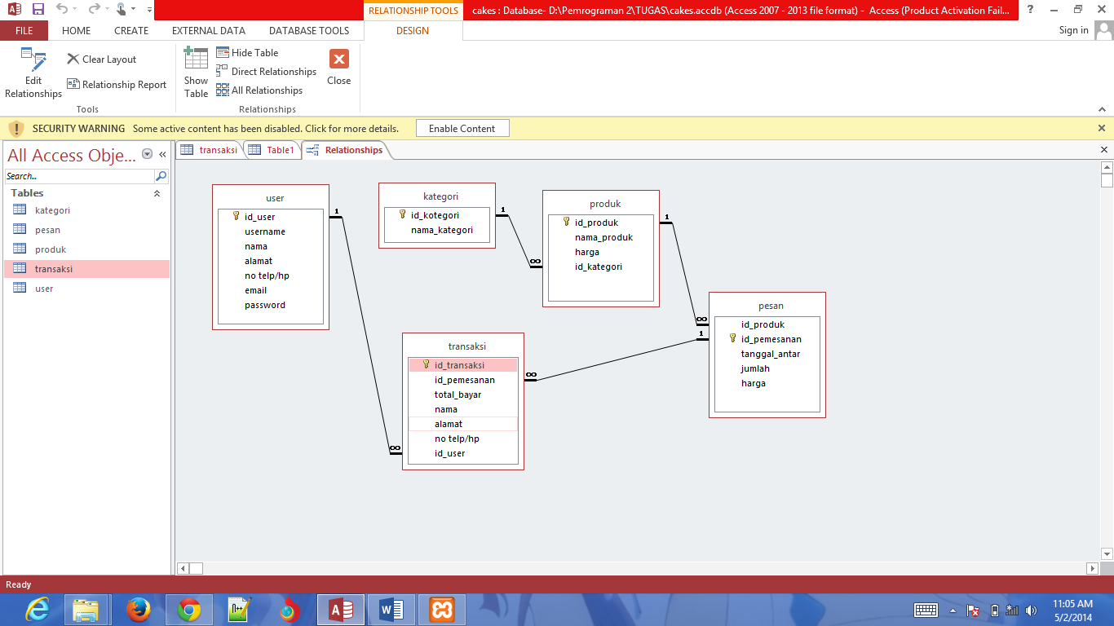

Rincian field

* Kategori

Table comments: kategori

|  |  |  |  |  |  |
| --- | --- | --- | --- | --- | --- |
| Column | Type | Null | Default | Comments | MIME |
| id_kotegori | varchar(255) | No |  |  |  |
| nama_kategori | varchar(255) | Yes | *NULL* |  |  |

Indexes

| Keyname | Type | Unique | Packed | Column | Cardinality | Collation | Null | Comment |
| --- | --- | --- | --- | --- | --- | --- | --- | --- |
| PRIMARY | BTREE | Yes | No | id_kotegori | 0 | A | No |  |

* Pesan

Table comments: pesan

|  |  |  |  |  |  |  |
| --- | --- | --- | --- | --- | --- | --- |
| Column | Type | Null | Default | Links to | Comments | MIME |
| id_produk | varchar(255) | Yes | *NULL* | produk -> id_produk |  |  |
| id_pemesanan | varchar(255) | No |  |  |  |  |
| tanggal_antar | datetime | Yes | *NULL* |  |  |  |
| jumlah | varchar(255) | Yes | *NULL* |  |  |  |
| harga | int(11) | Yes | 0 |  |  |  |

Indexes

| Keyname | Type | Unique | Packed | Column | Cardinality | Collation | Null | Comment |
| --- | --- | --- | --- | --- | --- | --- | --- | --- |
| PRIMARY | BTREE | Yes | No | id_pemesanan | 0 | A | No |  |
| id_produk | BTREE | No | No | id_produk |  | A | Yes |  |
| id_pemesanan | BTREE | No | No | id_pemesanan |  | A | No |  |

* Produk

Table comments: produk

|  |  |  |  |  |  |  |
| --- | --- | --- | --- | --- | --- | --- |
| Column | Type | Null | Default | Links to | Comments | MIME |
| id_produk | varchar(255) | No |  |  |  |  |
| nama_produk | varchar(255) | Yes | *NULL* |  |  |  |
| harga | decimal(19,4) | Yes | 0.0000 |  |  |  |
| id_kategori | varchar(255) | Yes | *NULL* | kategori -> id_kotegori |  |  |

Indexes

| Keyname | Type | Unique | Packed | Column | Cardinality | Collation | Null | Comment |
| --- | --- | --- | --- | --- | --- | --- | --- | --- |
| PRIMARY | BTREE | Yes | No | id_produk | 0 | A | No |  |
| id_kategori | BTREE | No | No | id_kategori |  | A | Yes |  |

* Transaksi

Table comments: transaksi

|  |  |  |  |  |  |  |
| --- | --- | --- | --- | --- | --- | --- |
| Column | Type | Null | Default | Links to | Comments | MIME |
| id_transaksi | varchar(255) | No |  |  |  |  |
| id_pemesanan | varchar(255) | Yes | *NULL* | pesan -> id_pemesanan |  |  |
| tanggal_antar | datetime | Yes | *NULL* |  |  |  |
| nama_produk | varchar(255) | Yes | *NULL* |  |  |  |
| jumlah | int(11) | Yes | 0 |  |  |  |
| harga | int(11) | Yes | 0 |  |  |  |
| total_bayar | int(11) | Yes | 0 |  |  |  |
| nama | varchar(255) | Yes | *NULL* |  |  |  |
| alamat | longtext | Yes | *NULL* |  |  |  |
| no telp/hp | varchar(255) | Yes | *NULL* |  |  |  |
| id_user | varchar(255) | Yes | *NULL* | user -> id_user |  |  |

Indexes

| Keyname | Type | Unique | Packed | Column | Cardinality | Collation | Null | Comment |
| --- | --- | --- | --- | --- | --- | --- | --- | --- |
| PRIMARY | BTREE | Yes | No | id_transaksi | 0 | A | No |  |
| tanggal_antar | BTREE | No | No | tanggal_antar |  | A | Yes |  |
| id_pemesanan | BTREE | No | No | id_pemesanan |  | A | Yes |  |
| id_user | BTREE | No | No | id_user |  | A | Yes |  |

* User

Table comments: user

|  |  |  |  |  |  |
| --- | --- | --- | --- | --- | --- |
| Column | Type | Null | Default | Comments | MIME |
| id_user | varchar(255) | No |  |  |  |
| username | varchar(255) | Yes | *NULL* |  |  |
| nama | varchar(255) | Yes | *NULL* |  |  |
| alamat | longtext | Yes | *NULL* |  |  |
| no telp/hp | int(11) | Yes | 0 |  |  |
| email | varchar(255) | Yes | *NULL* |  |  |
| password | varchar(255) | Yes | *NULL* |  |  |

Indexes

| Keyname | Type | Unique | Packed | Column | Cardinality | Collation | Null | Comment |
| --- | --- | --- | --- | --- | --- | --- | --- | --- |
| PRIMARY | BTREE | Yes | No | id_user | 0 | A | No |  |